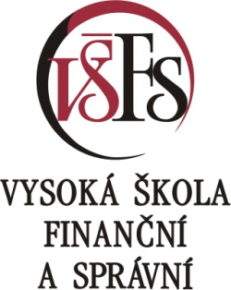

Contest for the Professor František Vencovský Award
7th ANNUAL COMPETITION 2019

Contest conditions and essay submission requirements

- The contest may be entered by contestants who meet the following requirements as of the closing date for contest submissions:
- are enrolled in doctoral study programs at universities with accredited doctoral studies programs in the Czech Republic,
- or have graduated from doctoral studies programs at universities within the past two years (decided by the date of completing studies as stated on the diploma).
Both domestic and foreign doctoral students (graduates) in full-time and part-time forms of study may participate in the contest.

- For essays written by multiple authors, the corresponding author shall submit the registration form and essay submission on behalf of the entire collective of authors. All members of the collective of authors must comply with the condition of doctoral studies stated in point 1.

- The registration form is available at the contest website:
https://www.vsfs.cz/cena/.

- Essay submission requirements:
a) the topic of the essay submission must match the theme announced for the contest,
b) the essay can be in the Czech or English language,
c) only an original essay that has not been published in a book or journal or accepted for publication may be submitted (prior publication in the form of qualification essays, conference submissions, or working papers are permitted),
d) the max. length of the essay is 20 PC pages (not including annexes), TNR 12, single spaced,
e) the essay must be sent without stating the name of the author(s) in the text, in a single file in PDF format, without information of any grant projects,
g) the essay should consist of title, abstract (max. 200 words), 4-7 key words or phrases (these sections must be in both Czech and English), JEL Classification. It shall include an introduction (stating the objectives of the research), the individual chapters, the conclusion (stating the findings of the research), a list of literature used, and any annexes.

- The registration form and essay submission must be sent by the deadline stated in the “Announcement of the 7th Annual Contest 2019” as email attachments to the address listed on the registration form.

- The contest nominations committee shall decide which of the two contest sections the entry will be assigned to.

- Contest entries will be judged by the nominations committee based on an evaluation of their quality. The nominations committee will be appointed by the Rector of the University of Finance and Administration. Contest entries will be judged on an anonymous basis.

- The winning essays win the financial award listed in the “Announcement of the 7th Annual Contest 2019”. The nominations committee reserves the right to divide or withhold the award.

- The announcement of contest winners will take place at a scientific conference, where notable experts and contest winners will take part.

- Contest participants will be offered the option to publish the winning essays in the scientific journal ACTA VŠFS.

