GUIDELINES FOR EDITING CONTRIBUTIONS
OF THE DOCTORAL STUDENTS CONFERENCE
AT THE UNIVERSITY OF finanCE aND ADMINISTRATION (2024)

Font type: Times New Roman, font size 12 (unless stated otherwise), block alignment, 1 free line at the end, 1.5 line spacing.
Contribution title: font size 16, centred, bold, according to sample (see template).
Contribution sub-title: author’s name and surname without degrees, centred,
font size 14.
Abstract: shall contain a brief outline of the problem addressed and the aims of the contribution, including the results achieved (do not copy paragraphs from the Introduction into the Abstract) – about 10 lines,
Key words: 4 – 6 words or phrases.
JEL classification see https://www.aeaweb.org/econlit/jelCodes.php.
Titles of individual contribution chapters: bold, numbering of chapters 1, 2, 3, subchapters 1.1, 1.2... maximum two levels.
Tables: tables should be presented according to the template, not in any other form.
Titles of tables and images: according to the sample in the template. Under the table or figure, indicate the source, namely in exact, traceable form.
Citations and references: according to the citation standard APA.
Subtitles: in the usual way, see sample.
Text highlighting: if absolutely necessary, use text highlighting in bold.

Possible dedication: reference to the research project, financial support, etc..
List of refrences used: alphabetically ordered list of references (without distinguishing the type), according to the citation standard APA, see template.
Author’s address: name and surname with titles, name and address of workplace (or other contact address), e-mail contact.
Paging: position – bottom, alignment - centre.
Indenting and numbering: use hyphens (-), numbering 1.

Contribution extent: approximately 5-10 pages (+ appendix + references).
Format: doc or docx.
The contribution can be submitted in Czech, Slovak or English version.

DO NOT use word hyphenation, fixed spacing, line breaks, page breaks, sections, automatic chapter, figures, charts and tables numbering, cross references etc. in your contribution.
Only one contribution will be accepted from each author (co-author).
Contributions will be peer-reviewed.
Contributions will not be subject to language editing and the authors are responsible for their accuracy.

The "Introduction" must explicitly state: The aim of the contribution is ...
In the "Conclusion" there must be an evaluation of aims set out in the Introduction.
The "References" shall only contain items mentioned (cited) in the contribution text.

Contribution Title
Author’s name and surname

Abstract
Abstract text, abstract text, abstract text, abstract text, abstract text, abstract text, abstract text, abstract text, abstract text, abstract text, abstract text, abstract text, abstract text, abstract text, abstract text, abstract text, abstract text, abstract text, abstract text, abstract text, abstract text, abstract text, abstract text, abstract text, abstract text, abstract text, abstract text, abstract text.

Key words
Key word, key word, key word, key word, key word

JEL classification

Introduction
Introduction text, introduction text, introduction text, introduction text, introduction text, introduction text, introduction text, introduction text, introduction text, introduction text.

1 Chapter
1.1 Sub-chapter

Contribution text, contribution text, contribution text, contribution text, contribution text, contribution text, contribution text, contribution text, contribution text, contribution text, contribution text, contribution text, contribution text, contribution text, contribution text, contribution text, contribution text, contribution text, contribution text, contribution text.

Table No. 1: Table title
Column 1 | Column 2 | Column 3 | Column 4 | Column 5
Row 1 | data | data | data | data
Row 2 | data | data | data | data
Row 3 | data | data | data | data
Source: Author’s own according to International Monetary Fund, 2013, pp. 20-25.

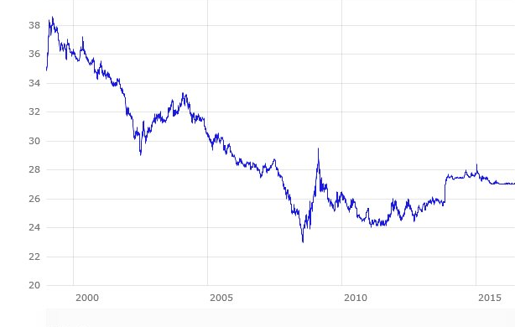
Chart No. 1: Image title
Source: Authors’ Compilation (2023)

Chart No. 1: Image title
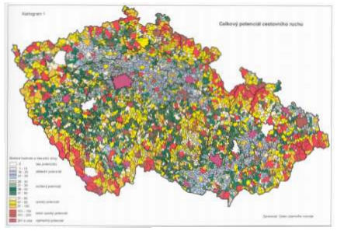
Source: Ústav územního rozvoje České republiky 2010

Contribution text, contribution text, contribution text, contribution text, contribution text, contribution text, contribution text, contribution text, contribution text, contribution text, contribution text, contribution text, contribution text, contribution text, contribution text, contribution text, contribution text, contribution text, contribution text, contribution text.

Contribution text, contribution text, contribution text, contribution text, contribution text, contribution text, contribution text, contribution text, contribution text, contribution text, contribution text, contribution text, contribution text, contribution text, contribution text, contribution text, contribution text, contribution text, contribution text, contribution text.

2 Chapter

Contribution text, contribution text, contribution text, contribution text, contribution text, contribution text, contribution text, contribution text, contribution text, contribution text, contribution text, contribution text, contribution text, contribution text, contribution text, contribution text, contribution text, contribution text, contribution text, contribution text.

2.1 Sub-chapter
Contribution text, contribution text, contribution text, contribution text, contribution text, contribution text, contribution text, contribution text, contribution text, contribution text, contribution text, contribution text, contribution text, contribution text, contribution text, contribution text, contribution text, contribution text, contribution text, contribution text.

Contribution text, contribution text, contribution text, contribution text, contribution text, contribution text, contribution text, contribution text, contribution text, contribution text, contribution text, contribution text, contribution text, contribution text, contribution text, contribution text, contribution text, contribution text, contribution text, contribution text.

Conclusion
Conclusion text, conclusion text, conclusion text, conclusion text, conclusion text, conclusion text, conclusion text, conclusion text, conclusion text, conclusion text, conclusion text, conclusion text, conclusion text, conclusion text, conclusion text, conclusion text, conclusion text.

Conclusion text, conclusion text, conclusion text, conclusion text, conclusion text, conclusion text, conclusion text, conclusion text, conclusion text, conclusion text, conclusion text, conclusion text, conclusion text, conclusion text, conclusion text, conclusion text.

Dedication

Please indicate here any reference to a research project, funding, etc., which you will highlight in italics.

Literature
Exapmles of bibliographic records
Books:
1. Bloom, D., Cashin, C., & Sparkes, S. (2017). Earmarking for health. Theory and Practice. Geneva: WHO.
2. Esping-Andersen, G. (1990). The Three Worlds of Welfare Capitalism. Cambridge: Polity Press.
3. Greer, L., Wismar, M., & Figueras, J. (2015). Strengthening health system governance: better policies, stronger performance. Brussels: European Observatory on Health Systems and Policies.

Journal article
1. Akazili, J., Gyapong, J., & McIntyre, D. (2011). Who pays for health care in Ghana? International journal for equity in health, 10(26).
2. Auerbach, A. J. (2010). Public Finance in Practice and Theory. CESifo Economic Studies, 56(1), 1–20. Available 14. 4. 2020, from http://iipf.org/rmvp08_auerbach.pdf.
3. Becker, G. (2007). Health as human capital: synthesis and extensions. Oxford Economic Papers, 59(3), 379–410.

Web portal
MISSOC. (2022). Mutual Information System on Social Protection comparative tables. Available 1. 2. 2022, from https://www.missoc.org/missoc-database/comparative-tables/.
Web document
1. WHO. (2018a). About social determinants of health. Available 1. 3. 2020, from WHO: https://www.who.int/social_determinants/sdh_definition/en.

Futher examples:
https://apastyle.apa.org/, https://guides.lib.ua.edu/APA7/starthere, https://pedagogika.phil.muni.cz/studium/citacni-norma-apa (in Czech language), https://www.griffith.edu.au/library/study/referencing/apa-7

Contact
Author’s name and surname (with degrees)
Organisation
Street
Postal code City
State
E-mail address
Appendix

Footnotes in the usual way. Alignment right, Times New Roman 10. References stated in the list of references used and cited in Harvard style as in the text.

